**Exception handling in java-**

Exception handling is the abnormal condition that occur during execution of program to stop the entire flow of application called as “Exception handling.”

Why?

**package** com.test;

**public** **class** Test {

**public** **static** **void** main(String[] args) {

System.***out***.println("First line");

System.***out***.println("Second line");

System.***out***.println("Third line");

}

}

Output-

First line

Second line

Third line

Now we add one exception line code as below

**package** com.test;

**public** **class** Test {

**public** **static** **void** main(String[] args) {

System.***out***.println("First line");

System.***out***.println("Second line");

System.***out***.println("Third line");

**int** a = 10 / 0;

System.***out***.println("Fourth line");

System.***out***.println("Fifth line");

}

}

Output-

First lineException in thread "main"

Second line

Third line

java.lang.ArithmeticException: / by zero

at com.test.Test.main(Test.java:10)

In this example, two statements are not executed, if you want to execute those two statements then how to do it in java? Then you should go for exception handling.

**package** com.test;

**public** **class** Test {

**public** **static** **void** main(String[] args) {

System.***out***.println("First line");

System.***out***.println("Second line");

System.***out***.println("Third line");

**try** {

**int** a = 10 / 0;

} **catch** (Exception e) {

System.***out***.println(e);

}

System.***out***.println("Fourth line");

System.***out***.println("Fifth line");

}

}

Output-

First line

Second line

Third line

java.lang.ArithmeticException: / by zero

Fourth line

Fifth line

Here two statements are executed i.e fourth line and fifth line, we have achieved this by using try and catch block.

**Exception hierarchy-**

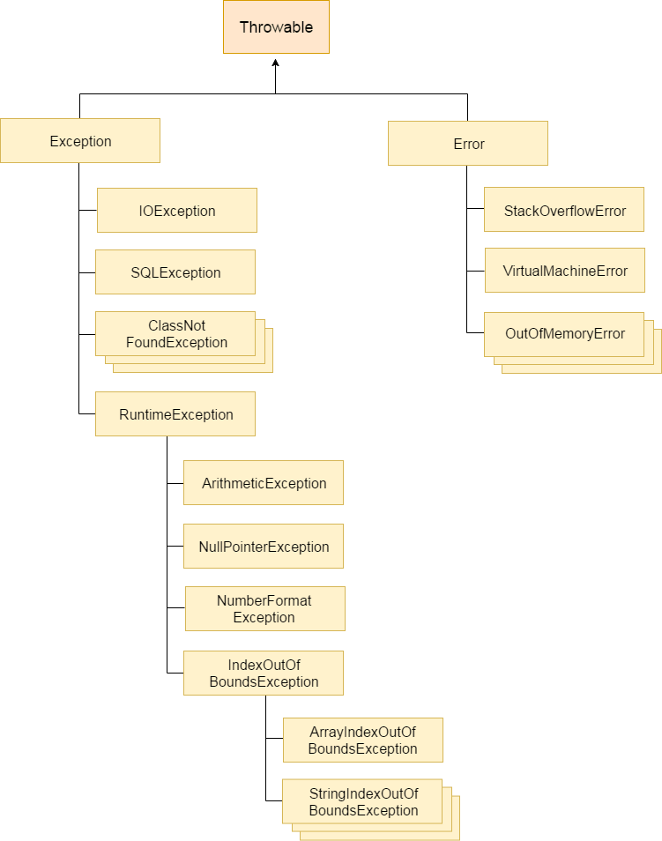

**Throwable-**

* In the above given Hierarchy Throwable is a class which is at the top of the exception hierarchy, from which all exception classes are derived.
* It is the super class of all Exceptions in Java.
* Both Exception and Errors are java classes which are derived from the Throwable class.

**Error-**

* Error is subclass of throwable class.
* Errors are mostly the abnormal conditions.
* Error does not occur because of the programmer’s mistakes, but when system is not working properly or a resource is not allocated properly.
* Memory out of bound exception, stack overflow etc., are examples of Error.

Difference between Checked and Unchecked Exceptions

1) Checked Exception

The classes which directly inherit from Throwable class except RuntimeException and Error are known as checked exceptions

Checked exceptions are checked at compile-time.

Example-

IOException

SQLException

2) Unchecked Exception

The classes which inherit from RuntimeException are known as unchecked exceptions.

Unchecked exceptions are not checked at compile-time, but they are checked at runtime.

Example-

ArithmeticException-

**package** com.test;

**public** **class** Test {

**public** **static** **void** main(String[] args) {

**int** a = 10 / 0;

}

}

Output

Exception in thread "main" java.lang.ArithmeticException: / by zero

at com.test.Test.main(Test.java:7)

NullPointerException

**package** com.test;

**public** **class** Test {

**public** **static** **void** main(String[] args) {

String str = **null**;

System.***out***.println(str.length()); //exception will be occured.

}

}

Output

Exception in thread "main" java.lang.NullPointerException

at com.test.Test.main(Test.java:8)

ArrayIndexOutOfBoundsException

**package** com.test;

**public** **class** Test {

**public** **static** **void** main(String[] args) {

**int** a[] = **new** **int**[5];

a[10] = 50; // ArrayIndexOutOfBoundsException

}

}

output

Exception in thread "main" java.lang.ArrayIndexOutOfBoundsException: 10

at com.test.Test.main(Test.java:8)

3) Error

Error is irrecoverable e.g. OutOfMemoryError, VirtualMachineError, AssertionError etc.

**Possible way to write try catch block**

1.

try {

//not allowed

}

2.

try {

//allowed

}

catch(Exception e){

}

3.

try {

//allowed

}

finally{

}

4.

try{

//allowed

}

catch (Exception e){

}

finally{

}

5.

try {

//allowed

}

Catch(ArithmaticException e1){

}

Catch(Exception e){

}

6.

try {

//not allowed

}

Catch(Exception e){

}

Catch(ArithmaticException e1){

}

Not allowed – What is the reason?

The bigger exception cannot be in the first catch because it will accommodate or handle all exceptions and there will be no chance to reach the second catch of NullpointerException

try{

}

catch(Exception e) {

}

catch(NullPointerException npe) {

}

8.

try {

// allowed

}

Catch(ArithmaticException e){

}

Catch(Exception e1){

}

**finally-**

The finally block is used when an important part of the code needs to be executed. It is always executed whether or not the exceptions are handled.

* Finally block will always get executed until we shut down JVM. To shut down JVM in java we call System.exit (). If you write this in try block in that case finally block will not be executed.
* Normally, finally block contains the code to release resources like DB connections, IO streams etc

Question. What is the difference Between Catch and finally in java?

|  |  |  |
| --- | --- | --- |
| Sr. No. | Catch | Finally |
| 1 | Catch block handles the error when it occurs in try block | There is no need of exception thrown by try block |
| 2 | Catch block is executed only when exception is thrown by try block, otherwise it is not executed | Finally block is always executed whether exception occurs or not |
| 3 | We can use multiple catch block for only one try block | Only one finally block is used for one try block |
| 4 | We can handle multiple exceptions by using catch blocks | It is not for exception handling |